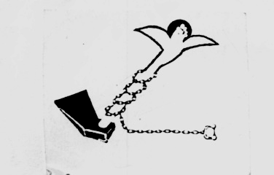

Land Center for Human Rights

Cairo15/2/2009 Press Release

.
El Horreya farmers will demonstrate today in front o the Ministry of Agriculture

Today , dozens of farmers from El Horreya village will head to the Ministry of Agriculture demanding to receive lands according to the President's promises in the last presidential elections. The farmers have applied several times to the Ministry of Agriculture to receive agrarian lands, but the Ministry didn't do anything about these requests. These farmers were among those who suffered from the implementation of law no 96 for the year 1992, they were lands tenants in Dekernes – Daqahleya governorate and were evicted out of their lands because of the implementation of this law that has ruined the relation between he tenants and the land owners. The negative effects of this law made the Ministry of Agriculture issue instructions to provide alternative lands to all the farmers who were evicted out of their lands because of this law. These alternative newly reclaimed lands will be located in many different parts of Egypt.
Unfortunately, the Ministry of Agriculture didn't provide these farmers with alternative lands, which make the LCHR demand the Minister of Agriculture to provide these farmers with alternative lands as an implementation to the law and a fulfillment to the presidential promises to guarantee farmers rights to working opportunities and decent living, as farming is their only source of income.
For more information, please contact the Center

For more information, please contact the Center.
ـــــــــــــــــــــــــــــــــــــــــ

Address: 122 el Gala’a st-Ramsis Tower-7th floor-Cairo
Tel/Fax: 02-25750470
E-mail: lchr@thewayout.net / lchr@lchr-eg.org
Website: www.lchr-eg.org

