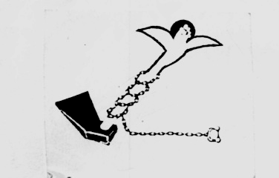

Land Center for Human Rights

Cairo 4/2/2009 Press Release

Communiqué to the Attorney General
Release our husbands and sons and implement the Court orders!!

On 5/2/2009, a number of lawyers along with dozens of wives, fathers, mothers and sons of detained workers and fishermen are going to the Attorney General's office because of the imprisonment of their family members in Borg El Arab prison, as these workers and fishermen are accused of facilitating travel abroad to young people illegally, despite the fact that the Egyptian courts have issued their decisions to release these men after proving their innocence. But the officers of the Ministry of the Interior are repeatedly issuing decisions to detain these victims, leaving the contractors, boat owners and corrupted officials who are considered the real criminals, giving them the chance to reproduce these crimes.

The families of the victims along with the lawyers are going to present a collective communiqué to the Attorney General against a number of officers who have arrested, humiliated, tortured and forced their family members to confess to crimes they didn't commit.

The LCHR along with these people and lawyers demand the Attorney General to release the detained workers and fishermen, investigate their issue and question the officers who have arrested them and humiliated them along with their families.

The LCHR also calls all civil society organizations and members of the people's and consultative councils to work on releasing these people, implement the law and guarantee their rights to freedom and safety.

For more information, please contact the Center.
ـــــــــــــــــــــــــــــــــــــــــ

Address: 122 el Gala’a st-Ramsis Tower-7th floor-Cairo
Tel/Fax: 02-25750470
E-mail: lchr@thewayout.net / lchr@lchr-eg.org
Website: www.lchr-eg.org

