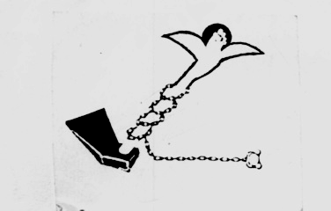

Land Center for Human Rights

Cairo 18/1/2009 Press Release

The poor fell victim to corruption
Why are Borg Megheizal fishermen being detained?
Is it of any justice to prosecute the victims and release the
criminals?
Under poverty and unemployment, many Egyptian youths seek illegal immigration either to Arab or foreign countries. These youths prefer to face death traveling to these countries or being arrested on the way there rather than to stay at their own country deprived of everything.

Because of that, the phenomena of illegal immigration by sea has been wide spread, and because of that, the Egyptian authorities have started arresting fishermen who live in the seaside areas of Mediterranean Sea especially those who live in Borg Megheizal – Markaz Metobas – Kafr El Sheikh. As 2 months ago, police forces have started arresting, mistreating and torturing more than 150 fishermen in that area accusing them of illegally transporting youths across the sea, while leaving boat owners and corrupted contractors do their worst. Although release notes have been issued for these fishermen, they are still detained in prison.

The LCHR has presented several complaints to many officials and the courts have issued decisions of releasing these fishermen but the Ministry of the Interior is still detaining them without any reason.

These fishermen are being arrested from their homes in the middle of the night terrorizing their wives and children, and in prison, they are mistreated, humiliated and tortured to be forced to confess to crimes they didn't commit.

The LCHR has presented 25 communiqués to the Attorney General to investigate these torture events.

The LCHR has also presented complaints to the Minister of the Interior, the Minister of Justice and Kafr El Sheikh Governor to intervene in these torture activities, release the detained fishermen and stop violating their right to personal safety.

The LCHR also calls the civil society organizations and members of the People's Assebly and the Consultative Council to work on releasing these fishermen especially those whom release notes have been issued for them, and guarantee people's rights in these villages to decent work, freedom and safety.

For more information, please contact the Center
ـــــــــــــــــــــــــــــــــــــــــ

Address: 122 el Gala’a st-Ramsis Tower-7th floor-Cairo
Tel/Fax: 02-25750470
E-mail: lchr@thewayout.net / lchr@lchr-eg.org
Website: www.lchr-eg.org

