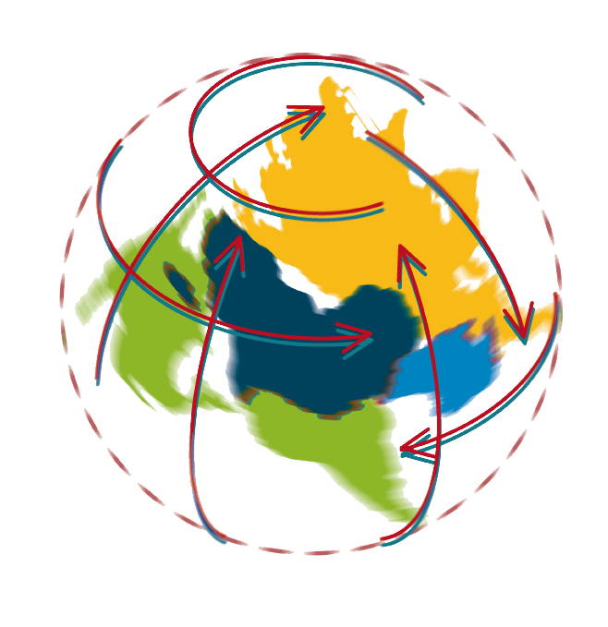
www.global-labour-university.org

WHAT LADDER? WHAT TREE?

GLOBAL DEVELOPMENT: CHALLENGES FOR UNION STRATEGIES

Call for Papers
International Workshop
at the
State University of Campinas
Campinas, São Paulo, Brazil
28-30 April 2008

Sponsors:  

Workshop background
The world has undergone profound changes in the last quarter of a century
- changes in international trade and investment regimes;
- changes in the institutions that regulate capital accumulation and income distribution at national levels;
- redefinitions of the boundaries between public and private space in the economy;
- growing influence of finance over production and service provision as sources of wealth.
As a consequence of those changes, economic growth has been accompanied by increasing inequality and insecurity for vast numbers of people both in rich and in poor countries. At the same time, imbalances between national economies and among regions within national economies have become more acute. Current trade and investment regimes backed by industrialised countries seem to severely restrain the ability of national policies that could help developing countries to “climb the tree” towards better economic and social conditions. To complete the picture, current growth patterns seem to result in unsustainable demands over natural resources. Not surprisingly, there is a growing feeling in developing countries about the urgency of a new development agenda. Unions must face the challenge of defining strategies to help build and advance such agenda.
The Global Labour University www.global-labour-university.org is a network of trade unions and universities that aims at facilitating research, debate and qualification programmes in order to address global labour issues. At its annual workshop in 2008 trade unionists and scholars are invited to present papers and discuss the challenges for organised labour as outlined in the two lead questions, which are elaborated on below.

1) Union strategies in the new international division of labour
The trade and investment regimes established in the mid 1990s promoted the restructuring of production and employment worldwide, increasing the market power of global Corporations vis-à-vis consumers, labour, local suppliers and governments. Global value chains are organized in forms that maximize value for share-holders even at the expense of the interest of other stakeholders. Corporate globalization, which is one of the main driving forces of current development trends, must be reassessed within the framework of a new development agenda.
Within the trade union movement there is a lively debate about responding to these new challenges by renewing and restructuring the international trade union movement and developing new tools like international framework agreements, MNC focussed global trade union networks, cross border agreements on principles for collective bargaining etc.
Papers are invited that:
a) assess trends and impacts of Global Value Chains restructuring for labour in goods and services, both for industrialised and developing countries;
b) analyse the impact of Multinational Corporation strategies concerning trade, foreign direct investment and taxation on state revenues, employment, labour conditions and assess current as well as potential Union strategies;
c) analyses current trends in trade negotiations and trade and investment agreements (bilateral, regional, multilateral) to maintain or strenghten the scope for national development strategies and assess the policies and impact of trade unions in these processes.
2) Towards socially and environmentally sustainable development: strategies for labour
Union responses are a major driving force of restructuring and an essential building block of the new development agenda. The effectiveness of Union responses will depend to a large extent on the ability to link employment and work conditions issues to other social actors and their concerns. Social and environmental sustainability are key issues that Unions must take into consideration in their contribution for a new development agenda. This raises the question to what extent contribute recent trade union actions like campaigns for decent work, global governance coherence, universal social security, living wages, labour standards in trade agreements or lending and public procurement to a wider development agenda?
Papers are invited that:

a) assess trade union strategies at local, national and international level for creating sustainable employment and improving income distribution, achieving living wages, increasing security, improving rights at work, , ;
b) assess the link between trade union agendas and broader issues of social and environmental sustainability;
c) critically address the relation between social and economic conditions, governance structures and viable trade union strategies;

Format

Theoretical and empirical studies should focus on current problems and their impact on labour as well as the implications for trade union practices. They should discuss possible policy options and trade union practices that could help strengthening Unions and broadening public support for a labour agenda.

The workshop will bring together an international group of scholars and trade unionists. It will feature working groups, paper presentations, and panel discussions involving both academics and trade unionists. Papers will be presented mainly in small interactive working groups to allow for in-depth discussion and development of ideas for possible future research and cooperation. A selected number of papers will be published in the 2008 GLU Yearbook
Papers can be submitted in English, Spanish or Portuguese.
Proposals for papers should be sent by 1 November 2007 to:

Prof Mariano Francisco Laplane,
Institute of Economics
State University of Campinas
Cidade Universitária CP 6135
13.083-857 Campinas SP
Brazil
e-mail glu.brazil@eco.unicamp.br
The proposal should be a two to three pages abstract that
1) gives the name, address and institutional affiliation of the author/s;
2) outlines the main idea; and
3) indicates what methodology will be used.

