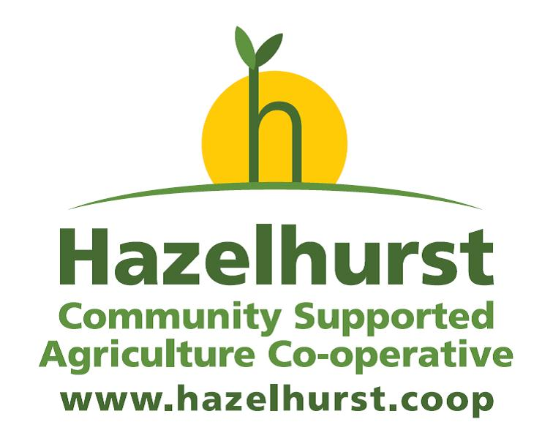

Newsletter no. 16 September/October 2013
Project Co-ordinator Update
After such a long and difficult winter what a fantastic summer we had! This meant long sunny volunteering days on the field and bumper harvests each week. We had more courgettes and beans than we knew what to do with. These not only filled the bags of our customers to bursting but also supplied the Gleadless Valley Foodbank for several weeks.
At the moment we have plump, ripe tomatoes, bunches of tropical looking rainbow chard, fistfuls of dark green Cavolo Nero kale and huge spaghetti squash.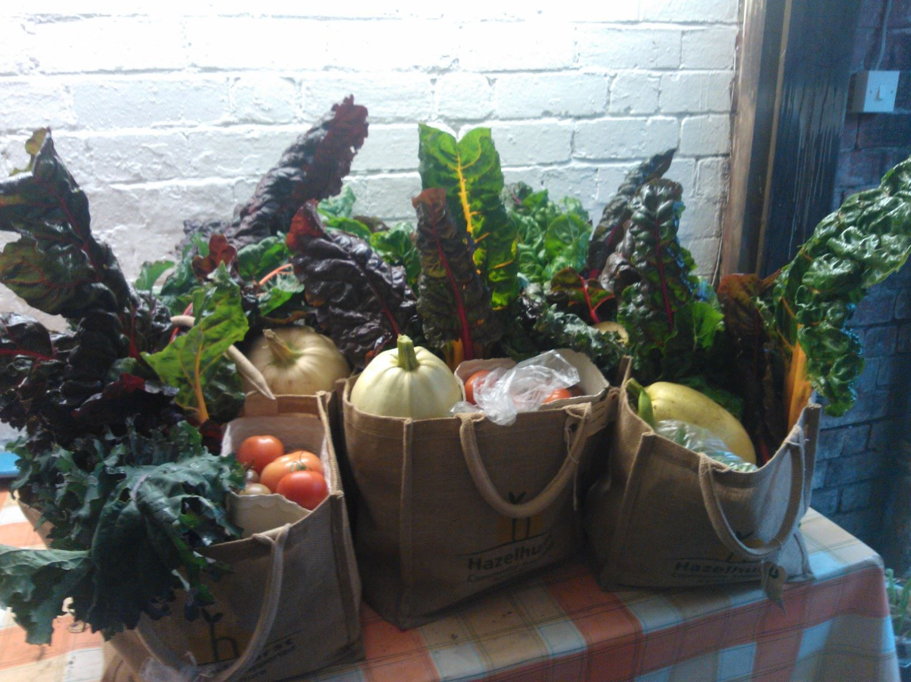
Due to people moving out of the area we have vacancies for a few more customers. If you want a bag or you know anyone else that does, please get in contact at vegbox@hazelhurst.coop or call 07857869740.
Each bag will contain potatoes, onions, carrots plus other seasonal vegetables.
Veg bag sizes and prices:
Large £13 (~ 10 types of vegetables)
Standard £11 (~ 8 types of vegetables)
Small £8 (~ 6 types of vegetables)
Changes to Hazelhurst CSA
Following a proposal passed at our AGM on Thursday 27th September, Hazelhurst CSA is taking a change in direction. From January 2014, Hazelhurst CSA will cease to employ our own Grower. Instead we will purchase most of our produce from Huw Evans and Martin Bradshaw, the independent growers who form part of Sheffield Organic Growers and who occupy the same field that Hazelhurst currently rents part of.

Hazelhurst will continue to deliver outreach initiatives and will continue to offer opportunities for volunteers to get involved with land-based projects and to keep the connection with the land.

We will continue to employ a co-ordinator to handle all the veg bag aspects of the co-op and to enable volunteering and outreach activity.

There was a strong feeling that there should be a follow up meeting to enable members to discuss some of the issues that came up.

The date for the follow up meeting is:

THURSDAY 24th OCTOBER, 6.30PM at SHARROW OLD JUNIOR SCHOOL.

We will discuss issues that came up at the AGM such as:

- Expanding our business
- Selling our 'surplus' veg
- Increasing our veg bag customers
- Staying connected to the land
- Concerns about 'giving up'
- Safeguarding the co-operative processes
- Communication and transparency
- Climate change and sustainability
- Bring other growers into the co-op
- Inter-dependence with ethical partners
- Volunteering
- Learning opportunities
- How to keep people engaged and involved
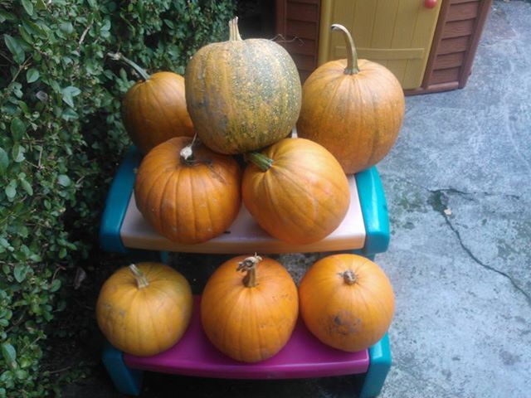
We hope that you can make it.

Hazelhurst Halloween Pumpkins

We have our own huge organic pumpkins available for a donation of £3. These are available to collect at the meeting at Sharrow Old Junior School on the 24th October or we can arrange for you to collect from Meersbrook. If interested please call or text Naomi on 07857869740.
A summary of the year as Volunteer Co-ordinator at Hazelhurst CSA
by Stella Hunt
Yes it is quite a walk to from the bus or tram stop and along Lightwood Lane, but it is a delightfully English walk. Turn your back on the city and enjoy blackthorn blossoms, musk roses, speedwell, and honeysuckle as eye candy for the journey. Then in autumn there are blackberries, rosehips, cuckoopint, holly and oaks and acorns adorn the hedgerows. People on horses will pass you by and it’s a favourite place for walkers, dog walkers and bird watchers alike. I can do the walk down the lane in 20 minutes now at best.
When volunteers reach the field they appreciate the wide open space of the south facing hillside and the beautiful views across the moss valley. As they work they become acquainted with the charms of the wildlife. Swifts, chiff-chaffs, wheat-ears, gold finches, woodpeckers, a yellowhammer. Bats, orange tip and peacock tail butterflies, cinnabar moths and wild geese. A flock of Canada geese that say ‘aah honk’, swans, a heron, a white owl in the snow, buzzards, kestrels, voles, hares, rabbits, foxes and badgers. Yesterday Denise spotted a weasel under the lock up you can tell it was a weasel because a weasel is ‘weasely recognised, whereas a stoat is stoatally different’!
Volunteering at Hazelhurst means you are doing something that helps combat climate change. Growing local organic food cuts fuel miles and helps maintain a reliable food supply when gas and oil shortages push up the price and availability of food.
We help cut fuel miles by sharing lifts to the field and by walking or cycling whenever possible. We bring gifts of home baking to share and cook soup in the winter. Volunteers have petrol and travelling expenses paid and vegetables to take home as a reward.
Lots of people have voted with their feet by volunteering at the CSA and helping on the land. Similar exciting projects are happening all over the world.
This summer we welcomed students volunteering with the ‘Summer Volidays’ scheme. On 15th of June I escorted 4 English Language students to the field on the tram. Foreign Students are always interested and excited to hear about Transition and how Hazelhurst began and they don’t want to sit about drinking tea either. They are keen to work hard and learn.
You never know when someone new will wander up the field coming to volunteer. This reminds us constantly that what we are doing is of great value.
I would like to say huge thank you to all the fantastic volunteers who have helped on the land this year. The amount of work we have achieved has been staggering.
Thanks especially to Carolyn who was our marvellous harvesting co-ordinator we wish her all the best now she has gone home to Canada.
Thanks to Alan who is our most stalwart volunteer this year and continues to work hard and make us all laugh at break times.
Rozzy Russell shares her car and always has a listening ear and a kind word and is quality control supervisor.
Rob and Kevin who worked long hours in the summer clearing and planting the poly-tunnel without these guys the hungry gap would have gone on longer.
Not forgetting very crucially the ‘waterers’ Naomi, Doug and our saviour Paul who incorporated the weekend watering into his morning running routine and sings at the same time.
One thing I have learned from volunteering at Hazelhurst CSA is that we have an innate need to connect with nature, the CSA allows us to do this and links farming to the community.
So, if the city is stressing you out, turn your back on it. Come and put world to rights whilst weeding the parsley patch.

Rita Wilcox is a valued member of our Outreach Group. She visited the Women’s Conversation Club in Lowedges. Here she tells us more:
The Lowedges Women’s Conversation Club meets every Tuesday from 1pm to 3pm at the Michael Church meeting room, Lowedges Road. On 3rd September I visited the conversation club. The group had already agreed that they would like me to tell them about both my role as Health Trainer in the Lowedges, Batemoor and Jordanthorpe communities and about the Hazelhurst Community Supported Agriculture (CSA) project, which I had described briefly in an email. First I described my work role and welcomed women to consider using the 1 to 1 support service at any time now or in the future. We had an interesting discussion about health issues affecting women in the group, and how important the group is for supporting each other and to women gaining in confidence.
Then I described Hazelhurst, showing photos from our newsletters; and the ideas behind it that brought it into being. I said how volunteers work on the land, and in organising and administrative roles, and get rewarded with ‘vegetable wages’. The women asked me questions, and were pleased to know that Hazelhurst is not far from where they live. I said that they are welcome to visit the field, if we arrange the trip in advance. The women were keen to do this, and put their names on a list of those interested. So this visit is to be arranged soon – before the cold weather sets in!
It was interesting to learn that 2 of the volunteer / members, Hadiah and Roza, have recently become volunteer Community Health Champions to support health-related activities in the Lowedges communities. They have been recruited with the help of Laura Norris, Community Health Worker, and will be mentored by Shelly Davis of the Energy Centre at Heeley City Farm.

Hazelhurst CSA makes Global Links
Part of my role at Hazelhurst involves making links with other community agriculture projects in the world. We are developing links with Savisthri, a women’s empowerment project in Sri Lanka and BHASO a project supporting people with HIV and Aids in Zimbabwe. Both projects have sent us an update on the work they are doing.
Thank you so much to Peter and Padma for taking the time out of their busy schedules to contribute to our newsletter. We look forward to working more closely and sharing news, information, farming methods, recipes and photos with you in the future.

BHASO empowering communities for self-sustenance.
By Peter Marimi
BHASO Training and Information Officer

In 2011 BHASO went into Nyikavanhu, a dry rural area in Masvingo Rural District characterized by poor rainfall and low crop yields. This was made possible under the PRP Phase 2 Food Security and Sustainable Livelihoods Programme that was supported by Oxfam GB and PRP. PRP is a consortium of funding organisations. In order to improve food security , nutrition and economic empowerment, BHASO identified 5 existing garden projects with potential and empowered group members with skills and vegetable seed as a pilot project. Group members were trained in soil fertility enhancement, seed bed preparation, farming as a business, Collection and Information Centre management and seed planting. A market appreciation tour to Chiredzi and Triangle was held in order to familiarize members with buyers and get a feeling of the kind of vegetables they would want to buy. After training the group members were provided with seed and pesticides and started planting. A Collection and Information Centre where all the 5 groups bring their produce before transportation to identified buyers in Chiredzi and Triangle was set up. A Marketing Task Force composed of representatives from each garden project oversees the collection, transport and sale of the garden produce. Individual members are then renumerated according to the quantities of their produce. More than 226 households are benefiting from these 5 garden projects.
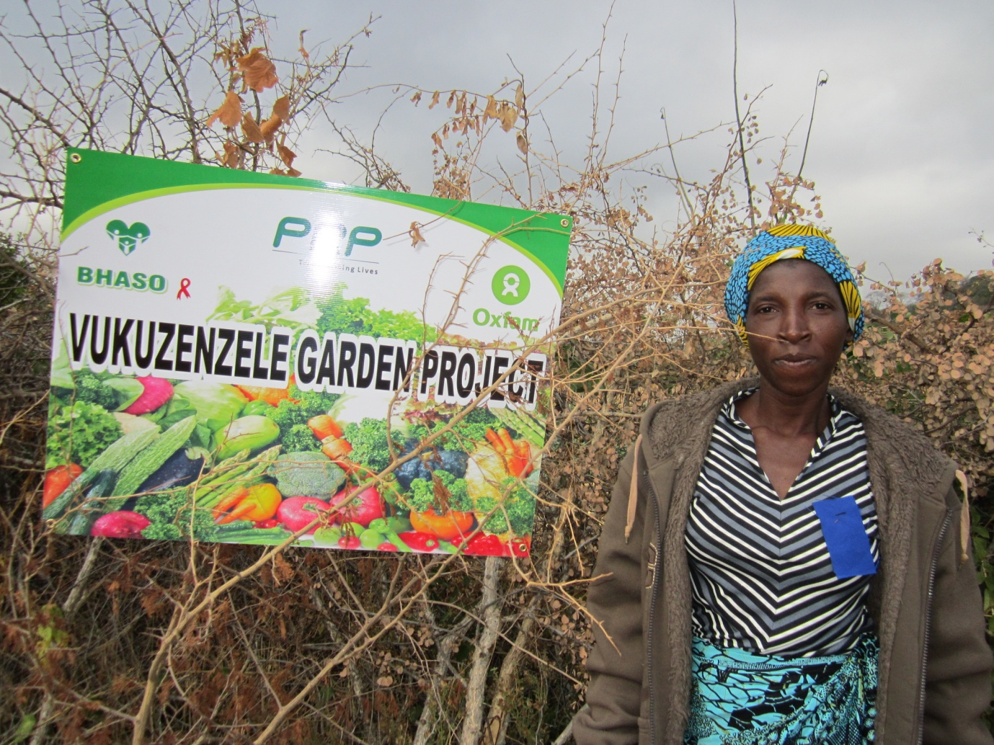
On 31 May 2012 more than 200 people gathered at the Vukuzenzele Garden Project located in Mudarikwa village under Nyikavanhu in Ward 29 of Masvingo Rural District some 160 km south of the ancient city of Masvingo. The happy occasion was a field day organized by the local community to celebrate the successes of the 5 garden projects that are being supported by BHASO. Also present were local traditional leaders, the local councillor, teachers, and staff from Ministry of Agriculture, Ministry of Health and Child Welfare, Oxfam GB and BHASO, a sign of BHASO’s ability to network and work with stakeholders.

A member of Vukuzenzele Garden Project proudly stands near the dry thorny branch fence protecting the garden

The field day was held at the Vukuzenzele garden because the group’s garden was selected as the best among the 5 gardens. A tour of the garden was proof enough as guests could not help admiring the stunning onion, cabbages, tomatoes and butternut that were being grown by the group with the butternut crop ready for sale. The garden was attractive enough to make a tourist attraction adorned as it was with healthy looking crops that compelled the onlooker to keep on looking. Here was a clear mosaic picture of commitment, hard work, resilience and teamwork. Vukuzenzele garden project members really deserved the first prize that was awarded to them. A new wheelbarrow full of picks, shovels and hoes was a fitting price as the tools are going to come in handy in the garden. The other groups received lower numbers of hoes, shovels, picks and vegetable seeds as runner up prizes.
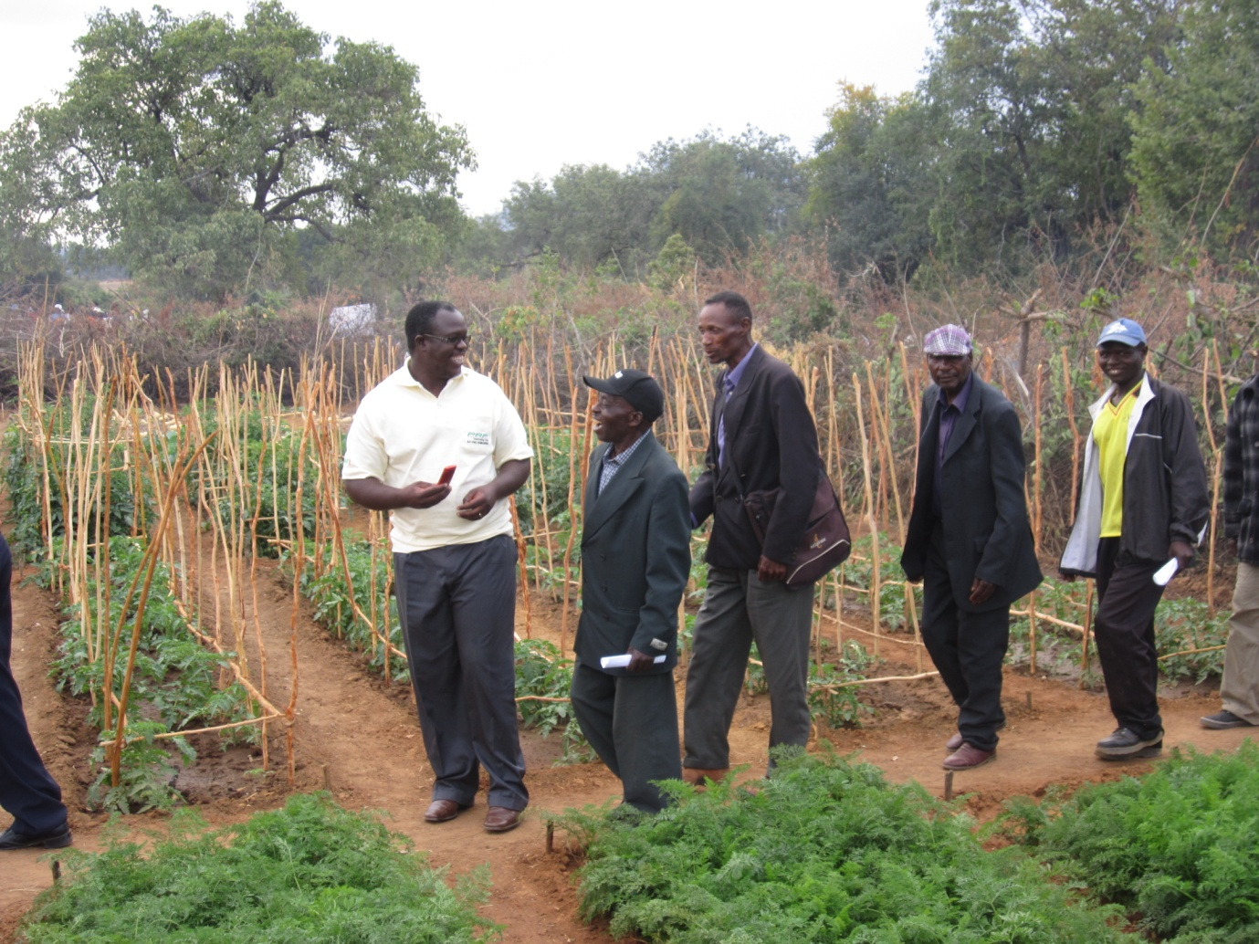
BHASO Director, Mr. Farai Mahaso being taken around the Vukunzele Garden.
Vukuzenzele, which means “wake up and do things for yourself”, was started some five years ago by a group of 35 villagers being 31 women and 4 men. The group was not doing very well until BHASO came in with training and material support like tools and vegetable seed.
With support from World Food Programme 4 of the 5 gardens have just been extended and properly fenced as they were all fenced by dry thorny branches. The extended gardens will enable more members to join the projects. Blair toilets have been constructed inside the gardens to improve on sanitation.

BHASO’s mission is “To empower people infected and affected by HIV and AIDS by providing services that will enable them to improve the quality of their lives”. BHASO has empowered 226 households in Ward 29 who are in the process of improving the quality of their lives nutritionally and financially by viably and sustainably growing vegetables. Once empowered, the empowered will be able to continue with their projects even in the absence of BHASO. Mission accomplished!
A Report from Padma Pushpakanthi, Savisthri in Sri Lanka
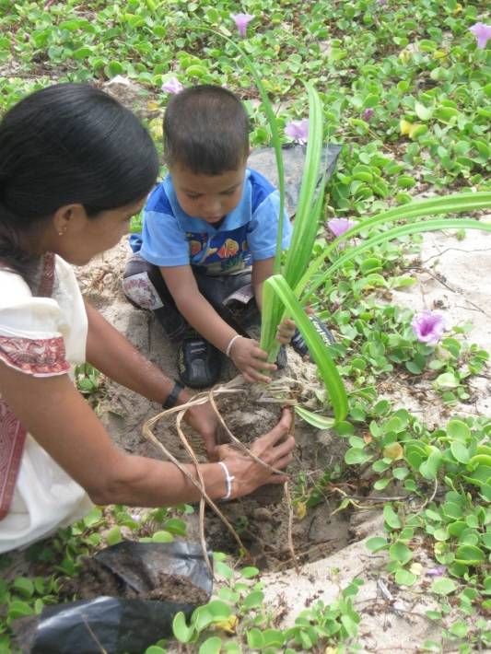
The “Savisthri” (Development Alternatives for Women) Movement has been implementing it’s programmes in Six District of Sri Lanka. These are Galle, Matara, Monaragala, Matale, Anuradhapura and Nuwara Eliya. It aims to for the uplift the poorest of poor women from the abyss they are and place them on a better footing socially, economically and politically. With this end in view we have been implementing several programmes in the Six Districts including ‘Home Gardening’ which has attracted the attention of the majority of our membership numbering 2441.
Each family has a home garden of it’s own with vegetables like beans, radish, leeks, pumpkin and bitter gourd and fruits such as mango, pomegranate, pineapples and guava. They also grow cereals like rice and green gram sorghum. No chemicals are used in such fields. Instead organic fertilizer made out of dried leaves, hay and kitchen refuse is used which is devoid of any poisonous stuff to enable the farmers to collect a harvest consisting of items of nutritious value.

We had six foreign funding organisations earlier but now it has dwindled to two due to the existing global economic crisis. At the initial stages, Savisthri spent vast sums of money to train the members how to prepare the soil using poison free fertilizers and taught methods of destroying weeds without utilising weedicider etc. Savisthri provided high quality seeds – which enabled the members to collect a good harvest, part of which is being used for home consumption and the extra sold either to the neighbours or at their own sales outlets..
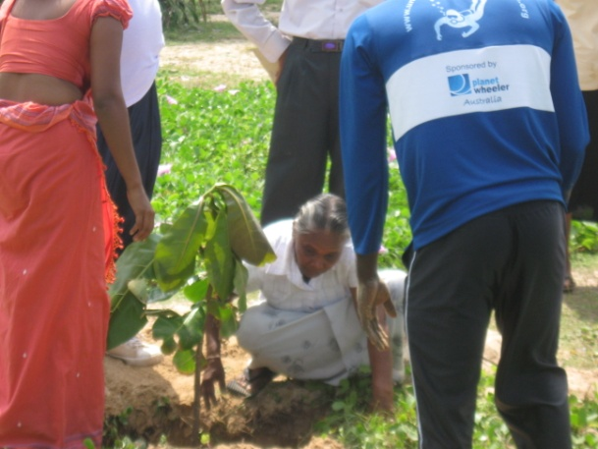
Although the members try hard to protect their fields, natural disasters had obstructed their activities. At first the tsunami which caused havoc in Sri Lanka in December 2004. completely devastated the lands full of crops especially in the Southern Province of Sri Lanka including the Districts of Galle and Matara in addition to the destruction of their dwellings and the disappearance of several thousands of humans. Now all the Sri Lankans are threatened with continuous heavy rains, landslides, occasional thunder-bolts all due to the global warming and the resultant climate change.
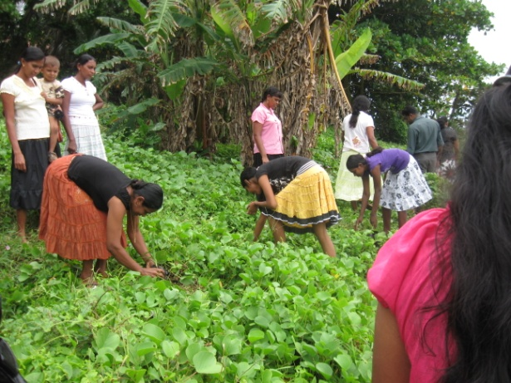
Heavy rains which result in floods, submergence of paddy fields and the home gardens have caused immense damage to them putting the farmers in great difficulties. Since they depend on the harvest of their crops for survival this has become a severe problem to them. In view of the fact that the lands get submerged with flood waters and this situation continues for several days, all the crops cultivated get destroyed and the farmer has to take the trouble of growing them again. To avoid a recurrence of this, the farmers follow several tactics like making simple drainage systems so that the water flows down. Cereals like rice, vegetables, yam and green leave are those that do not withstand stagnant waters.
In between, Sri Lanka experiences hot spells too where the rivers, tanks and reservoirs get dried up due to lack of rain. In such instances when there is a scarcity of water for drinking purposes too and for the plants and trees which need water, farmers use a system whereby the water collected in large containers during the rainy season is transferred to the vegetable beds through small pipe lines drop by drop during hot spells. In certain other instances, a large pit is dug at the end of a slope in the garden where the rain water is automatically drained into it and this water is utilized to water the plants in hot weather.
Like what you are doing at Hazelhurst in Sheffield, in Sri Lanka too farmers engage the poor members during the periods of ploughing, sowing and harvesting and they are paid in cash or harvest for their labour.
In Monaragala which lies in the Dry Zone of Sri Lanka farmers are faced with several problems from wild animals like elephants, monkeys and peacocks who come in herds and destroy the crops. Due to the continued protests from the farmers steps have already been taken by the government to erect electric fences to ward off the elephants. The menace from monkeys and peacocks remains to be solved.

