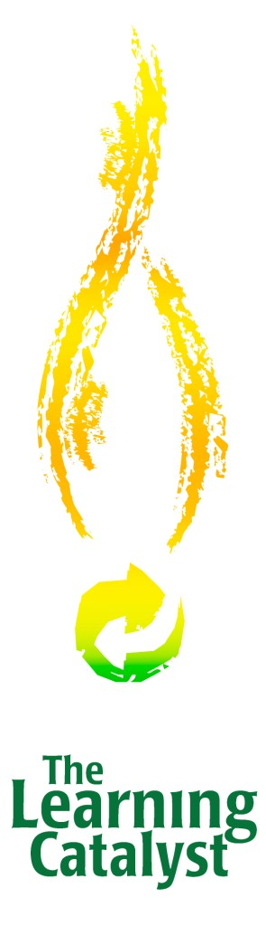
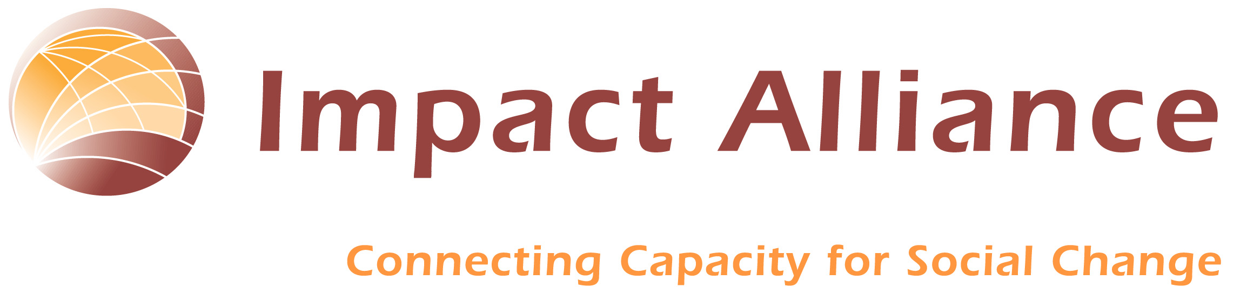
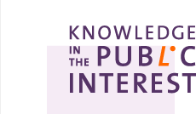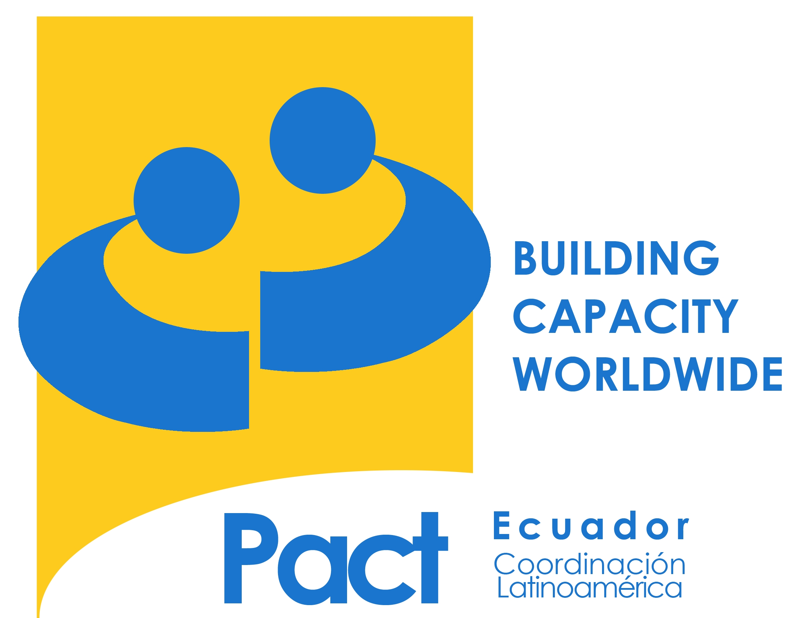


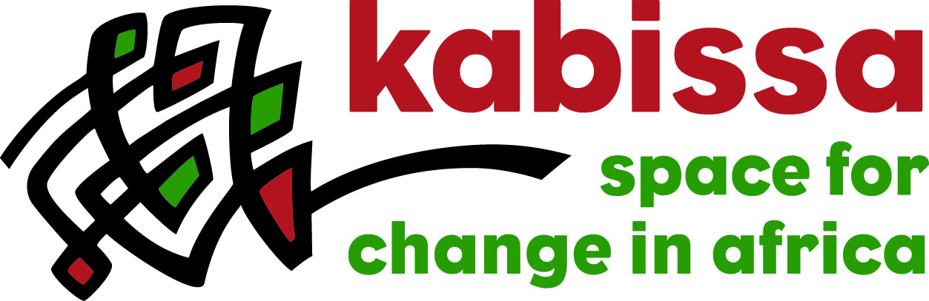


Dear ___

You are invited to the first Global JAM on Online Communities for Social Innovation, July 18-19. A JAM is an online discussion that is time limited, asynchronous, moderated, and subsequently analyzed.

Online communities are changing the work we do and how we do it. They are creating new avenues for learning and innovating. They drive new models of leadership.

Today’s technologies while plentiful are not inventoried, and overall not adequate for the needs of the social sector. The goal of this JAM is to help the sector use online community tools more effectively and to help technologists to build more appropriate tools. Through this discussion we hope to create a shared vision of our collective future for online communities for social change and innovation.

Participants will include leaders of nonprofit, NGO, public sector and grantmaking organizations, researchers and academics, technologists, and consultants from around the world. All use or plan to use online communities for social innovation.

We hope you will join us in this important conversation. The “Price of Admission” is completing the short survey at http://tinyurl.com/36cqk7

The JAM will be analyzed and synthesized in the form of a “white paper” that you will have the opportunity to participate in writing. You will receive a final copy, though we imagine it to be more of a living, changing piece. The paper will list all the JAM participants (unless you do not want to be identified).

JAM details can be found at kpublic.net and at the beginning of the survey.

We look forward to seeing you there.

Cheers from all…

