SATURDAY 10TH JUNE 2023
Bankside Open Spaces Trust terms and conditions for
Community Stall Holders

TIMES
Hours of trading: 12.00pm – 08.00pm
Set up times: 7.00am – 10.30am
Stall holders with vehicles must be parked by 10.00am (parking on Ayres Street will be offered on a first come, first served basis otherwise vehicles will need to be parked on surrounding roads)
No deliveries will be allowed to enter the site after 10.30am
All stalls must be ready for inspection by 11.00am
Site clear up and pitch vacation from 7.00pm to 10.00pm
No vehicles to move onsite between 10.30am - 9.00pm

As soon as possible you must provide the completed form (below) for your organistation by email to festival@bost.org.uk - you will then be sent your site access details two weeks before the Festival

ARRIVALS
Vehicles are not permitted to drive on site without the guide of the parking/ market stall steward
All vehicles MUST NOT drive above 5mph
ALL vehicles must STOP when told to do so
All vehicles must display hazard indicator flashing lights whilst moving around the site at all times
GENERAL GUIDELINES
a) Allocation of stalls and sites will be at the discretion of the event/site managers. No discussions will be entered
into. Size of single market stall pitches are 7ft x 3ft – picture below of a double stall

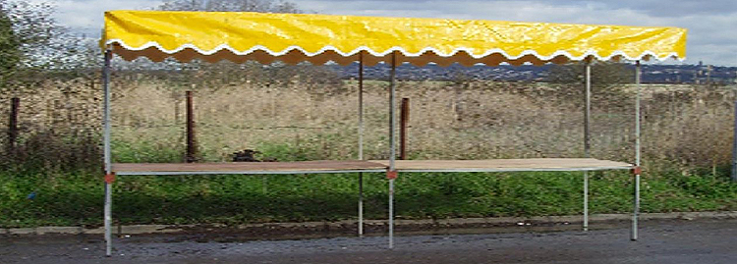

b) All stall holders must apply to all health and safety guidelines relating to stall set up and fire briefings
c) Stallholders must have an up-to-date risk assessment, ensuring that it is available on the day and will abide by organisers risk assessment
d) Stallholders will be responsible for providing their own equipment to dress their stall
e) Staff need to be 16 years or older and be eligible to work in the UK
f) Behaviour deemed inappropriate and not conducive to fair trading may lead to the trader being asked to
cease trading
g) Stall holders should keep stall free from refuse and clean as they go along, and rubbish should be taken away offsite when you leave
h) Your area is to be left clean, tidy and damage free at the end of trading

CANCELLATIONS & REFUNDS
a) All stall booking payments are strictly non-refundable unless otherwise agreed with the site/event manager
b) The stallholder shall not have any claim against the organiser in respect of any loss or damage upon the
event’s failing (for whatever reason) to be held or the event’s venue being or becoming wholly or partially
unavailable for the holding of the event for whatever reason
c) The organiser will not be responsible for any loss or damage to personal property or cash. Bankside Open Spaces Trust is not liable for loss of revenue to the stallholders in any circumstances whatsoever

POSTPONEMENT OR ABANDONMENT
a) The stallholder shall not have any claim against the organiser in respect of any loss or damage upon the
event’s failing (for whatever reason) to be held or the event’s venue being or becoming wholly or partially
unavailable for the holding of the event for whatever reason
b) The organiser will not be responsible for any loss or damage to personal property or cash. Bankside Open Spaces Trust is not liable for loss of revenue to the stallholders in any circumstances whatsoever

LIABILITY
a) The stall holder is required to have taken out product and public liability insurance of at least £1
million. (Please send relevant docs with signed registration form)
b) The organiser shall not be liable for any loss or damage (including consequential or indirect loss or
damage) suffered by the stall holder whether such loss or damage arises from breach of a duty in
contract or in any other way (including loss or damage from the organiser’s negligence) and which
shall include (but not by way of limitation) loss of profit; loss of contracts; loss of or damage to property or
goods of the stall holder or any other person; or personal injury to the stall holder or any other person
(but only so far as such injury is not caused by the organiser’s negligence)

FIRE PRECAUTIONS
a) Stall holders must comply with all instructions given by the relevant authorities to avoid the risk of fire or any
other risk
b) All electrical appliances must be in safe working order and PAT tested within the last 12 months

ITEMS FOR SALE
a) All stall holders must fully comply with Sales of Goods Act and all related Trade Description Acts
b) You should only be selling items agreed on this form

By taking part in this event, you agree to have your photo taken or image recorded by video, which can be
used for marketing purposes in the future

Bankside Open Spaces Trust reserves the right in their absolute discretion to make any changes or
cancellations it considers necessary

REGISTRATION FORM FOR COMMUNITY STALL HOLDERS

Stallholders Particulars

Name of Community Stall
Name of Lead Person
Address

Mobile number
Email
Vehicle Registration (please provide the reg of the vehicle you plan to arrive in on the day if you are driving on-site)
Crew Names
Any other specific requirements
Twitter handle:
Facebook page link:
Instagram handle:
Website link:
Hashtags:
If you wish to send any marketing material/ images to us please email MaryT@bost.org.uk with the subject title: BOSFest 2023 (insert company name) marketing.

The contact person serves as a link between you and BOST Festival organisers. The representative must be easily reachable and capable of making decisions.

Product Details - if applicable
Provide a full list of products that you plan on selling;

Items for sale:

Packaging used (e.g., is it sustainable?):

Selling Handmade Beauty Products
Notification to Department for Business, Innovations and Skills | Yes  No 
Notification to Trading Standards | Yes  No 
Cosmetic Product Safety Report | Yes  No 
Product Information File | Yes  No 
Products labelled for ingredients | Yes  No 

On the return of this form, you will be sent an invoice for the below amount to be paid before the date specified – ONLY if you are selling items onsite otherwise your stall will be FOC.

Fee per community stall | £25.00 | To be paid by Friday 5th May 2023

NO LATE OR PART PAYMENTS WILL BE PERMITTED.

Documents required if applicable

Insurance | Attached Yes  No 

Declaration
All applicants must sign this form. Forms that are not signed will not be considered.

I declare that the above-mentioned information is true and correct. I agree to submit all the required certificates, and make payment. By signing this document, I confirm that I am fully authorised to sign the application form. I commit myself as a debtor with respect to adhering to the obligations as set out above.

I confirm that I have read the terms and conditions and agree to abide by them.

Signature:
Print Name & Surname:
Date:

